The web works thought servers and browsers communicate via HTTP,then HTTP ensures that all parts of the web page are delivered finally web browser decided how these items are displayed

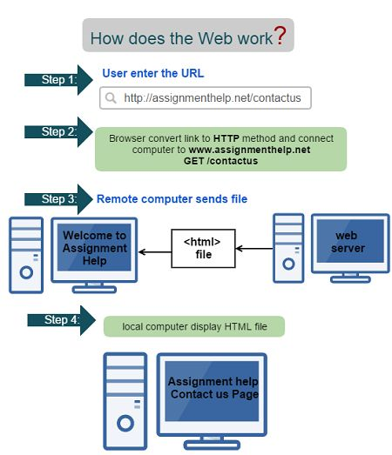To become a Web Developer, you should have **an understanding of HTML, CSS, and JavaScript**. It's also recommended to learn about CSS and CSS frameworks. Developing these fundamental web development skills will give you the foundation and logic for communicating with programming languages.

Web development **gives me the opportunity to express myself creatively on the internet**. If i have an idea i would like to try as i discover my web dev skills, try it out. Web dev is a fun, creative experience.